**In this lab we will setup an Instance group and will also create a new instance using it.**

**Instance Group:-**

1. Go to disks, create image of boot volume of cat1

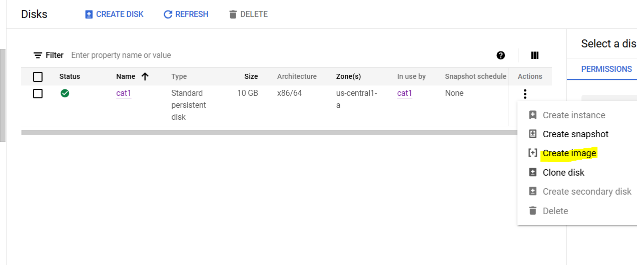

1. 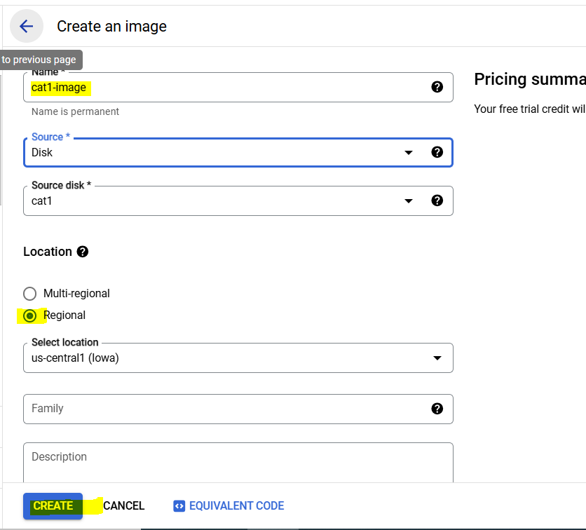
2. Go to instance template>create instance template

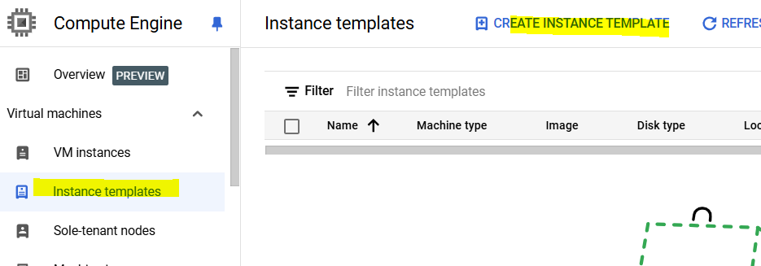

1. Give it a name, keep regional and E2 family shape (already be default)
2. Scroll down. Click change under boot disk, select custom images, change disk type to standard persistent disk and select cat1 image created above

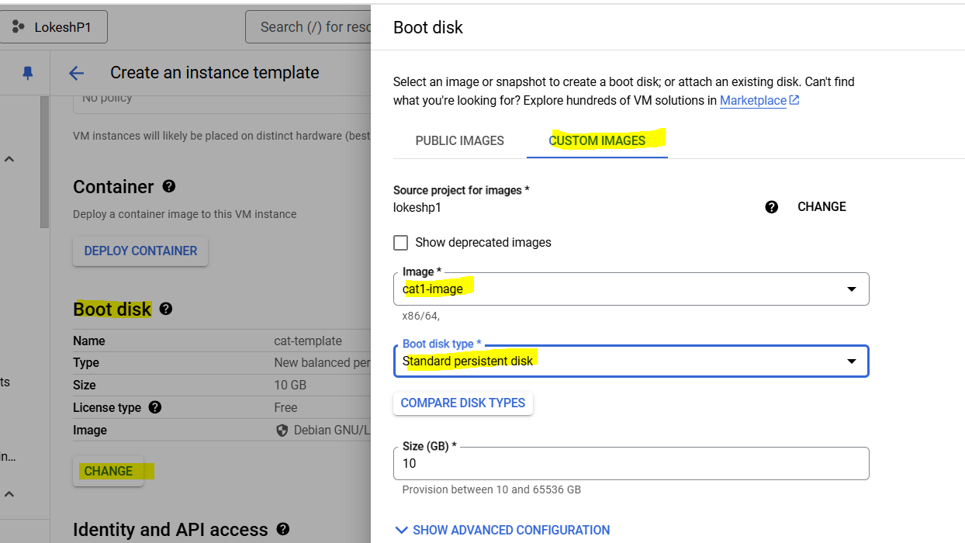

1. Allow http and https traffic

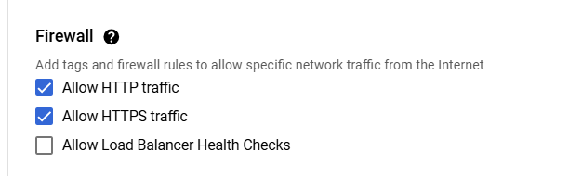

1. Expand advanced option, go to Management and paste below startup script

**Note:- make sure to update username in script**

#!/bin/bash

export ASPNETCORE_ENVIRONMENT=Production

cd /home/{USERNAME}/catalog

dotnet catalog.dll

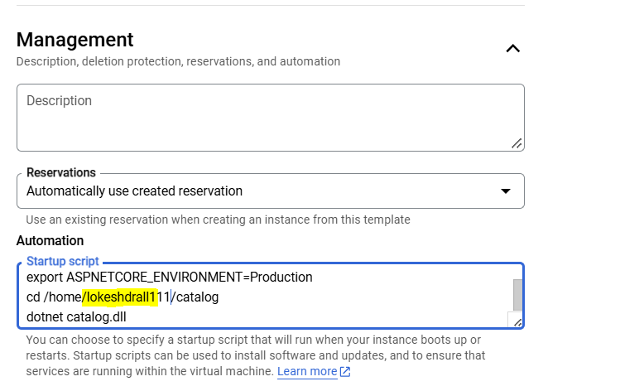

1. Click create
2. Go to instance group and click create instance group

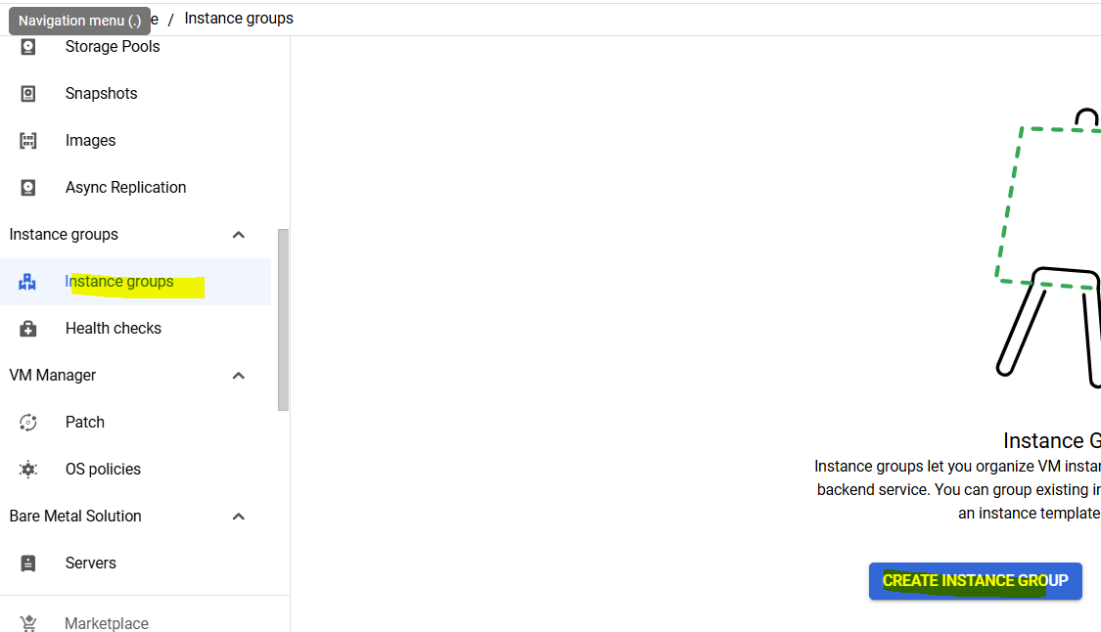

1. Give name and select the template

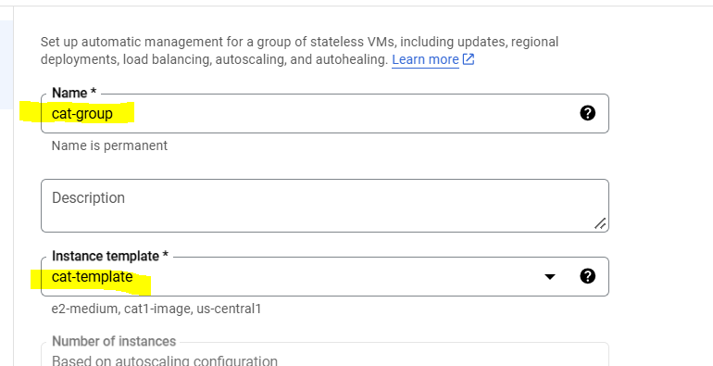

1. Explore other options like location, autoscallng but keep them default
2. Click create
3. Now once instance group is created, it will start creating the minimum number of instance which we gave 1 while creating it

Sooner it will create a new instance, check it under instance page. Try access ReadIt app via Ip of this new vm, it should work